Using Windows Live Movie Maker

Create a short video using MovieMaker to demonstrate a concept, idea or topic. You can use images or video for the content and you can use music, voice or a combination of both for the background.

**Step 1:** Log-In to a PC and create a folder on the desktop entitled Movie Maker practice. To create a folder, right click on the Desktop🡪Click on New🡪Click on Folder.

**Step 2:** In the folder, place at least 5 images, 30 seconds of film or a combination of both. You can use YouTube, or any resource for the content. *This part takes the most time.*

**Step 3:** In the folder, place at least 30 seconds of sound. The sound could be a voiceover(see step 7) or background music from another source. Sound can be a .wav, .mp3 or .m4a. If you want to combine multiple tracks, like music and voice, you must use Audacity. I have placed samples you can use in the Z Drive.

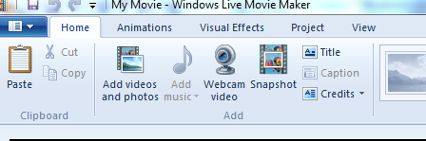**Step 4:** Open Windows Live Movie Maker by clicking the Start button. In the search box, type Movie Maker, and then, in the list of results, click Windows Live Movie Maker. On the Home tab click **Add videos and photos**.

In the **Add Videos and Photos** dialog box, open the folder that contains the photos or videos that you want to add, select the video files and photos, and then click **Open**. To select multiple photos and videos, press and hold the Ctrl key, and then click each photo and video you want. Visit <http://goo.gl/w955K> for help.

**Step 5:** You have a couple of options for this step.

1. (Easy)You can try to make an **Auto Movie.** This link explains how to create an Auto Movie: <http://goo.gl/p2D3L>.
2. (Hard)You can try editing on your own.
   * You can lengthen or shorten your images. Click on the image that you would like to lengthen or shorten. Click on the **Duration box** in the **Video Tools** tab. Select the amount of time you need for this image.( <http://goo.gl/gaaqY>)

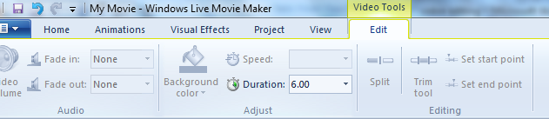

* + You can trim your video clips.
    - Click the video clip that you want to trim. Click the **Trim Tool** under the **Video Tools** tab. Drag the point to where you want the video to start and end. Watch this clip for help: http://goo.gl/y6WJJ.

**Step 6:** Import and Edit the Audio that you made in **Step 3**.

* On the Home tab click **Add music**.
* In the Add music dialog box, open the folder that contains the sound file that you want to add, select the file, and then click **Open**. Your audio automatically adjusts to the length of your video but you can override the start and end times using the tools. Watch this clip for help: http://goo.gl/jF49u.
* Adjust the volume and fading by clicking on the clip and then using the **Music Tools** tab. \**To delete the sound of an existing video, click on the clip and then the* ***Video Tools tab****. Lower the volume by sliding the scale to the left in the* ***Music volume icon****.*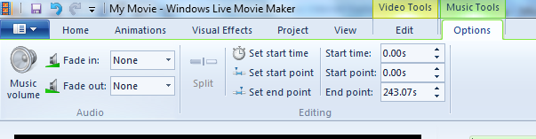

**Step 7: Optional:** You can narrate your video using the Record narration button. Learn more here: <http://answers.microsoft.com/en-us/windowslive/forum/moviemaker-av/how-to-record-narration-in-movie-maker-2012-and/33de1195-6c52-46c4-8cf6-19dbd1f2154c>

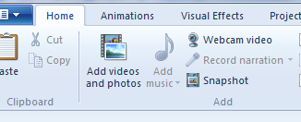

**Step 8:** If you finish early, experiment with **the Visual Effects** tab as well as the **Animations** tab.

**Step 8**: Save your project on your I-drive or a flash drive. Click on the small saving menu button. Select Save movie🡪 For Computer🡪Navigate to your I-Drive/Flash Drive.

